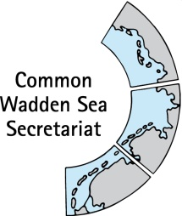
DRAFT AGENDA v0.1
Expert group Climate Change Adaptation
(EG-C 5)
12 May 2020
Virtual meeting

- Opening of the Meeting and adoption of the Agenda
The meeting will be opened by the Chairperson at 13:30 hours on 12 May 2020.
Proposal: Adopt the draft agenda of the meeting

- Adoption of the draft summary record
Document: EG-C5-2-SREG-C4
Proposal: Adopt the draft Summary Record of EG-C 4

- Announcements
Document: EG-C5-3-Announcements
Meeting participants are invited to hand in their information to the CWSS until 05 May 2020. Individual announcements will not be repeated, but time given for questions [all].
Proposal: Note the information

- Interreg Building with Nature
Document: EG-C5-4-BwN
Information on Building with Nature Interreg project [Julia].
Proposal: Note the information

- Climate Vulnerability Index (CVI)
Document: EG-C5-5-CVI Workshop report
Information on CVI Workshop and review draft workshop report [Robert, Julia].
Proposal: Note the information, revise the document and discuss next steps.

- Single Integrated Management Plan (SIMP)
Documents: EG-C5-6-SIMP-Coastal-protection, SIMP joint meeting_draft summary record_17Feb.docx
Information on SIMP progress and review of draft SIMP key topic chapter “impacts from outside - coastal flood defence and protection” [Julia, Robert].
Proposal: Note the information, revise the document and discuss next steps.

- Any Other Business and next meeting
Discuss any other business and next meeting.

- Closing
The meeting will be closed no later than 16:30 hours on 12 May 2020.

