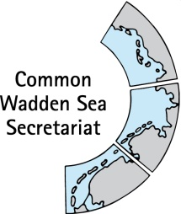
MEETING DOCUMENT
Task Group World Heritage (TG-WH 30)
29 April 2020
Virtual Meeting

Agenda Item: 5
Subject: Status of World Heritage activities in Supplementary Budget 2020
Document No.: TG-WH 30/5/3
Date: 25 April 2020
Submitted by: CWSS

The Supplementary Budget 2020 was approved by the States Parties in beginning of 2020. The status of World Heritage activities and costs distribution regarding the Supplementary Budget is provided in separate Excel file (status April 2020).

Proposal: The meeting is invited to take note respectively to comment on the status.

