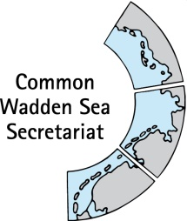

TASK GROUP
World Heritage
TG-WH 41
24 March 2023
Online Meeting

_________________________________________________________________________

Agenda Item: 3

Subject: Announcement DK

Document No. TG-WH 41/3/1

Date: 16 March 2023

Submitted by: Danish Wadden Sea National Park

_________________________________________________________________________

Currently the Danish Government are screening for areas suitable for possible testing sites for wind mills. The testing sites will comprise up to 8 tall wind mills up to 450 m height. It is a screening process so far for wind conditions, number of inhabitants and military interests. No other circumstances have been taking into account. Three possible sites within the National Park area are in the screening process.

It has raised serious concerns in the National Park board, in the municipalities and among the public evidently because a possible testing site is incompatible with World Heritage, National park, N2000 and other nature protection measures but also cultural landscapes and e.g. churches.

The National Park has held two public meetings to inform the public about what is ongoing (even though we know only a few things) and to give the public a room to raise their concern. Also, the responsible minister for spatial planning has visited the National Park.

We know that the local community on Mandø has contacted UNESCO to raise their concern for the UNESCO World Heritage designation (and the foreseen designation as Dark Sky Park).

A decision by the government/parliament is still way down the road and is not taken until after a screening for environmental implications. Some of our colleagues from DE and NL has been informed by Janne Liburd and Peter Saabye Simonsen.

